Campus Helpdesk and Service Portal

Information Systems Project Management
1902478

Done by:
Huda Alsayed 2213316
Yaqout Bani Melhem 0189655
Hamzeh Ali 2213243
Asmaa Abd Almahdi 0217045
Nabil Alnatsheh 0218909

Supervised by: Dr. Rana Youssef

Table of Contents
Chapter One: Introduction about the systems and its objectives 4
1.1 Background and Business Need 4
1.2 Project Overview 4
1.3 Project Objectives 5
1.4 Target Users 5
Chapter Two: functional and non-functional requirements Architectural model and use case diagram 6
2.1 Functional Requirements 6
2.2 Non-Functional Requirements 7
2.2.1 Usability Requirements 7
2.2.2 Performance Requirements 7
2.2.3 Security Requirements 7
2.2.4 Reliability and Availability Requirements 7
2.2.5 Maintainability Requirements 7
2.3 Architectural Model 8
2.3.1 Presentation Layer 8
2.3.2 Application Layer 8
2.3.3 Data Layer 8
2.4 Use Case Diagram 10
2.4.1 Actors 10
2.4.2 Main Use Cases 10
Chapter 3: project management documents 12
3.1 Project Management Tool Screenshot 12
3.2 Project Charter 13
3.3 Gantt Chart and Work Breakdown Structure (WBS) 13
3.4 Resource Breakdown Structure (RBS) 14
3.6 Risk Worksheet 14
Chapter 4: User manual………………………………………………………………………….24

Figure 1: The Architectural Model for the Campus Helpdesk and Service Portal. 9
Figure 2: The Use Case Diagram for the Campus Helpdesk and Service Portal. 11
Figure 3:Jira Project Access and Team Roles Screenshot 12
Figure 4: University support system logo. 15
Figure 5: Home page 16
Figure 6:Home page 16
Figure 7:Login page. 17
Figure 8: Admin page. 18
Figure 9: Admin page. 18
Figure 10 :FAQ 19
Figure 11 :Library or Housing 19
Figure 12:FAQ page. 20
Figure 13: registration 21
Figure 14: submit a ticket &chat bot 21
Figure 15: Campus Helpdesk Bot 22
Figure 16: Submit Ticket 24
Figure 17: Rate your experience. 25

Chapter One: Introduction about the systems and its objectives

1.1 Background and Business Need
In modern academic environments, students and staff frequently require assistance related to campus services such as information technology support, academic registration, financial inquiries, and general administrative issues. However, these services are often delivered through fragmented communication channels, including emails, phone calls, and in-person visits. This fragmentation results in delayed responses, repeated inquiries, lack of transparency, and inefficient service delivery.
Students and staff may have trouble identifying the correct support channel for their issues, while support teams face increased workloads due to recurring questions and untracked requests. These challenges highlight the need for a centralized and efficient digital solution that can streamline campus support services, improve response times, and enhance overall user experience.

1.2 Project Overview
The Campus Helpdesk and Service Portal is designed as a unified digital helpdesk platform that centralizes all campus-related support services into a single, accessible web-based system. The platform integrates automated and human support mechanisms by combining a categorized FAQ system, an AI-powered chatbot, and a ticket management system.
The system enables users to obtain instant answers to common questions through FAQs and AI assistance. When an issue cannot be resolved automatically, users can submit a support ticket, which is then tracked until resolution. This approach improves transparency, ensures accountability, and enhances communication between users and support staff.

1.3 Project Objectives
The primary objectives of this project are:
- Centralize all campus help and support services into one unified portal.
- Streamline support processes and reduce response time through AI automation.
- Provide real-time assistance using both AI and human support.
- Enhance user satisfaction by offering transparent ticket tracking and feedback mechanisms.
- Reduce repetitive inquiries through an automated FAQ system.
- Improve service quality and operational efficiency across campus support units.

1.4 Target Users
The Campus Helpdesk and Service Portal is designed to serve the following user groups:
- Students: who seek assistance related to academic, technical, and administrative issues.
- Staff and Support Agents: who manage and respond to submitted tickets.
- System Administrators: who oversee system content, manage FAQs, and ensure smooth system operation.
Each user group is provided with appropriate access and functionalities based on their role within the system.

Chapter Two: functional and non-functional requirements
Architectural model and use case diagram

2.1 Functional Requirements
Functional requirements describe what the system is expected to do and the services it must provide to its users. The functional requirements of the Campus Helpdesk and Service Portal are defined as follows:
FR1 The system shall allow users to authenticate using student and staff demo accounts.
FR2 The system shall allow authenticated users to access the platform based on their assigned roles (student, staff, or admin).
FR3 The system shall provide a categorized Frequently Asked Questions (FAQ) section covering topics such as IT services, registration, finance, and general inquiries.
FR4 The system shall allow users to search FAQs using keywords.
FR5 The system shall integrate an AI chatbot to provide instant responses to common user queries.
FR6 The system shall allow users to submit a support ticket if their issue is not resolved through FAQs or the AI chatbot.
FR7 The system shall store ticket details including issue description, category, submission date, and priority.
FR8 The system shall allow users to track the status of submitted tickets (open, pending, closed).
FR9 The system shall allow support staff to view, respond to, and update ticket statuses.
FR10 The system shall provide an admin dashboard for managing FAQs and support tickets.
FR11 The system shall allow administrators to add, edit, and delete FAQ entries.
FR12 The system shall allow users to submit feedback and a satisfaction rating after ticket resolution.

2.2 Non-Functional Requirements
Non-functional requirements define the quality attributes and constraints of the system.

2.2.1 Usability Requirements
- The system shall provide a user-friendly and intuitive interface.
- The system shall be easy to navigate for users with minimal technical knowledge.
- The interface shall be responsive and usable on desktops, tablets, and mobile devices.

2.2.2 Performance Requirements
- The system shall load main pages within an acceptable response time under normal usage.
- The AI chatbot shall respond to user queries promptly.
- Ticket status updates shall be reflected in real time or near real time.

2.2.3 Security Requirements
- The system shall restrict access using user authentication.
- The system shall enforce role-based access control for students, staff, and administrators.
- User data and ticket information shall be protected from unauthorized access.

2.2.4 Reliability and Availability Requirements
- The system shall ensure reliable ticket storage without data loss.
- The system shall remain available to users during standard operational hours.
- The system shall handle multiple user requests without failure.

2.2.5 Maintainability Requirements
- The system shall allow administrators to update FAQ content without developer assistance.
- The system shall support future enhancements such as additional service categories.

2.3 Architectural Model
The Campus Helpdesk and Service Portal follows a three-tier architectural model, which separates the system into presentation, application, and data layers. This architecture improves scalability, maintainability, and security.

2.3.1 Presentation Layer
This layer represents the user interface and includes:
- Student and staff user portal
- Admin dashboard interface
- AI chatbot user interface
The presentation layer handles user interactions and displays system outputs.

2.3.2 Application Layer
This layer contains the core system logic and services, including:
- Authentication and authorization services
- FAQ management service
- Ticket management service
- Feedback management service
- AI chatbot processing component
It processes user requests received from the presentation layer and communicates with the data layer.

2.3.3 Data Layer
This layer manages data storage and retrieval and includes:
- User database
- FAQ database
- Ticket database
- Feedback database
The data layer ensures persistent and secure storage of system data.
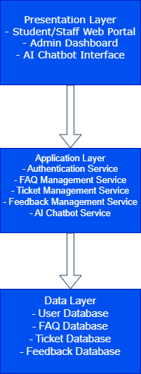

Figure 1: The Architectural Model for the Campus Helpdesk and Service Portal.

2.4 Use Case Diagram
The use case diagram represents the interactions between system users (actors) and the system functionalities.

2.4.1 Actors
- Student/User: Accesses FAQs, interacts with the AI chatbot, submits tickets, tracks ticket status, and provides feedback.
- Staff/Support Agent: Views and responds to tickets and updates ticket status.
- Administrator: Manages FAQs and oversees ticket handling.

2.4.2 Main Use Cases
- Login to the system
- Browse and search FAQs
- Interact with AI chatbot
- Submit support ticket
- Track ticket status
- Respond to and update tickets
- Manage FAQs
- Submit feedback and satisfaction rating
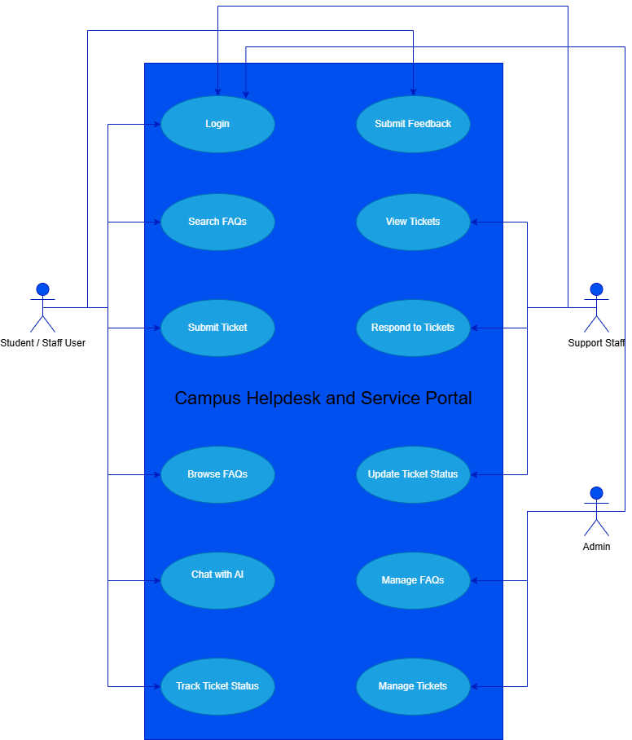

Figure 2: The Use Case Diagram for the Campus Helpdesk and Service Portal.

Chapter 3: project management documents
This chapter presents all project management documents that were prepared and submitted during the semester for the Campus Helpdesk and Service Portal project. These documents were used to plan, manage, monitor, and control the project activities and resources. The documents are presented in the order required and reflect the actual project management artifacts produced throughout the project lifecycle.

3.1 Project Management Tool Screenshot
Figure 3.1 presents a screenshot of the project management platform used to manage and track the project tasks and team roles. Jira was used to organize work items, assign responsibilities, monitor progress, and manage collaboration among team members throughout the semester.
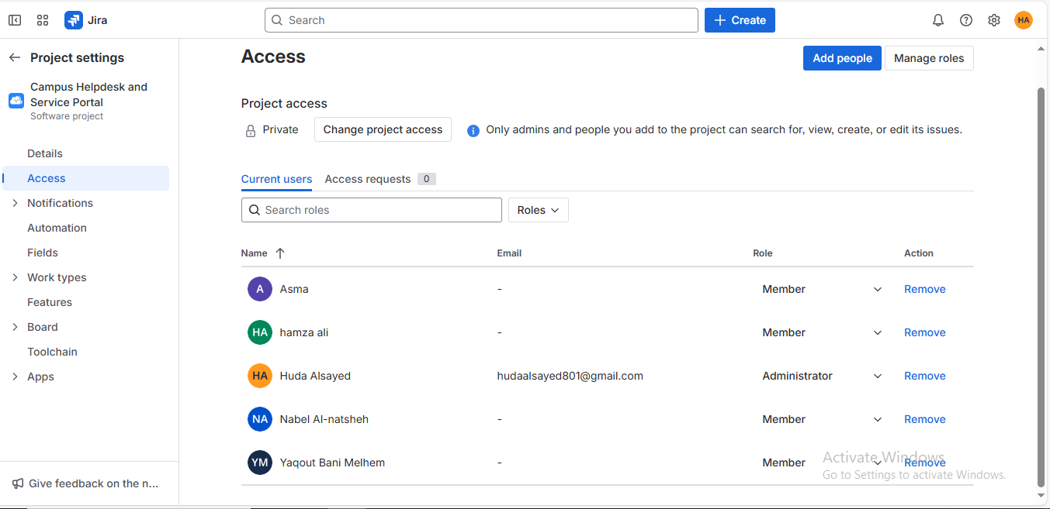
Figure 3:Jira Project Access and Team Roles Screenshot

3.2 Project Charter
The Project Charter defines the overall direction, objectives, scope, stakeholders, milestones, risks, assumptions, and constraints of the Campus Helpdesk and Service Portal project. It formally authorizes the project and provides a clear reference for decision-making throughout the project lifecycle.
The Project Charter includes:
- Business need and project objectives
- Project requirements
- Product description and deliverables
- Stakeholders and assigned roles
- Summary milestone schedule
- High-level risks, assumptions, constraints, and acceptance criteria

3.3 Gantt Chart and Work Breakdown Structure (WBS)
The Gantt Chart and Work Breakdown Structure (WBS) were used to plan and visualize the project timeline, tasks, and dependencies. The Gantt Chart illustrates the project schedule across the academic semester, while the WBS breaks the project into manageable phases, tasks, and subtasks.
These documents helped the team track progress, manage deadlines, and ensure that all required activities were completed on time. The project tasks were organized into major phases such as planning, design, development, integration, testing, and documentation.

3.4 Resource Breakdown Structure (RBS)
The Resource Breakdown Structure (RBS) identifies and organizes all resources required for the successful completion of the project. The RBS categorizes resources into human, technical, financial, and other supporting resources.
The RBS includes:
- Human resources such as project manager, developers, AI specialist, QA and documentation lead, and test users
- Technical resources including development tools, hosting services, databases, and APIs
- Financial resources covering hosting, software licenses, and operational expenses
- Other resources such as time, documentation, and work environment
The RBS ensured efficient resource planning and allocation throughout the project duration.

3.6 Risk Worksheet
The Risk Worksheet was prepared to identify, analyze, and document potential risks that could affect the successful completion of the Campus Helpdesk and Service Portal project. This worksheet was created during the project kickoff phase and served as a proactive risk management tool throughout the semester.
The Risk Worksheet includes:
- Identification of potential project risks
- Assessment of risk impact and likelihood
- Proposed mitigation and response strategies
- Ownership and monitoring responsibility for each risk
Key risks addressed in the worksheet include technical challenges related to AI chatbot accuracy, limited development and testing time within the academic semester, and coordination risks among team members. By documenting these risks early, the project team was able to plan appropriate mitigation actions and reduce the likelihood of negative impacts on project delivery.

Chapter 4: user manual
Campus Helpdesk and Service Portal

Figure 4: University support system logo.

4.1The unified platform for university support towards a faster and smarter service using artificial intelligence and integrated human support.

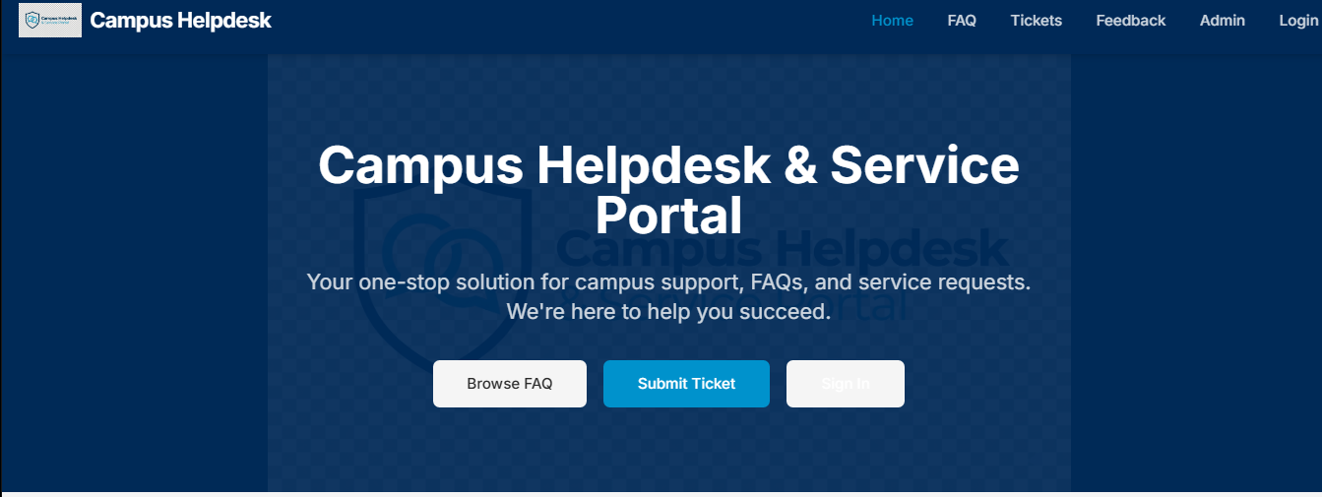
2
4
3
1
Figure 5: Home page

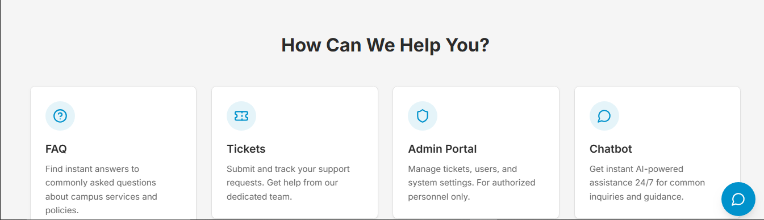
5
Figure 6:Home page
.
4.2 .Home page: this page is your gateway to all university support services.
Instructions:
- Main menu.
- Browse by topic.
- Send ticket.
- Sign in.
- Automated assistant.

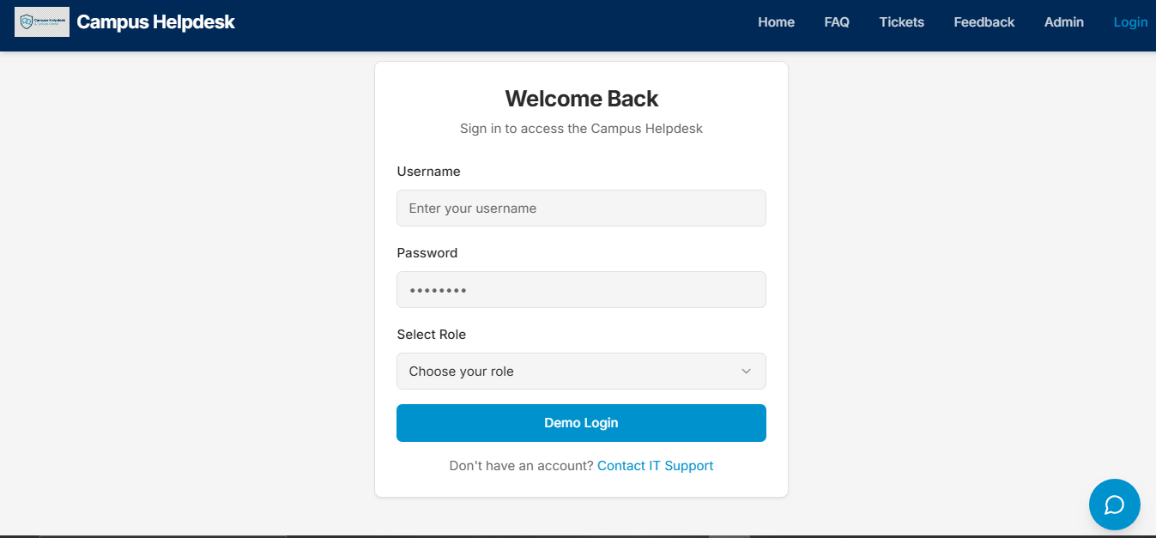
5
4
3
2
1
Figure 7:Login page.
4.3 Login Page
This page is designed to secure access for registered users to their personal accounts and control panel. It ensures information security while providing a smooth and fast login experience.
Instructions:
- Username/Email Field: Enter your university email address or username registered in the system.
- Password field: enter your account's secret password.
- Select Role option: This menu allows you to select your role within the system for a personalized experience.
- Demo login option: quick access to a trial system without a personal account.
- Link to create a new account: for new users who don't yet have an account.

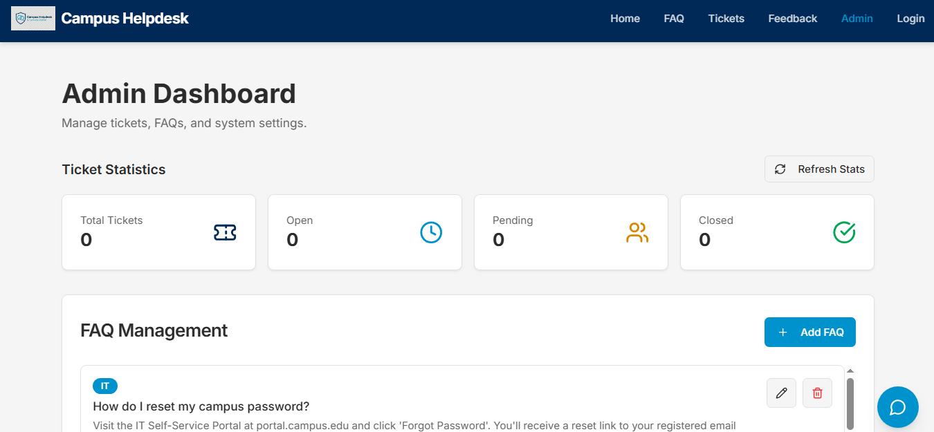
4
5
1
3
2
Figure 8: Admin page.
.

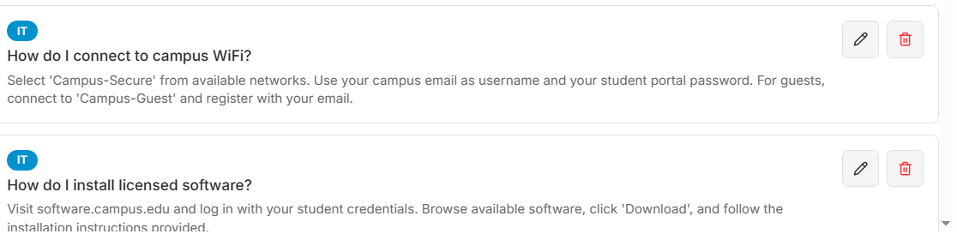
6
Figure 9: Admin page.

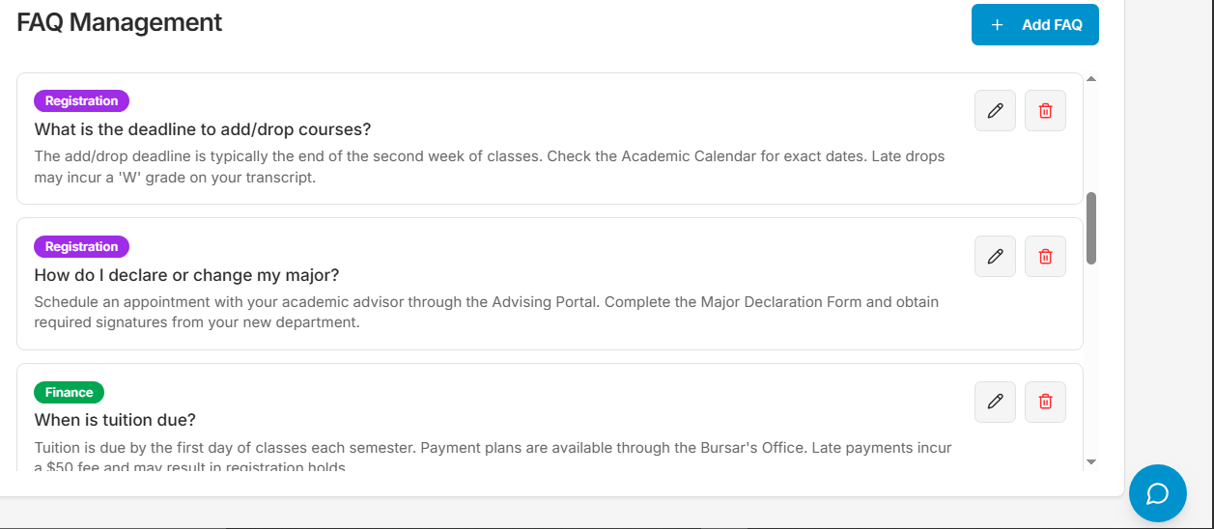
6
Figure 10 :FAQ

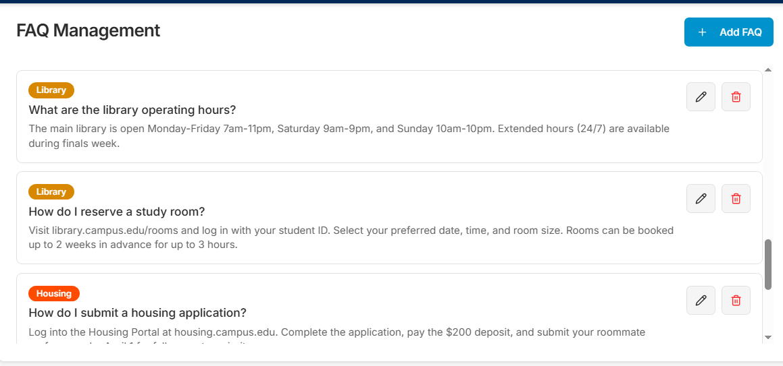
6
6
Figure 11 :Library or Housing

4.4. Comprehensive control center for managing the system, its content, and its users.
The administrator control panel is the main interface for administrators and authorized staff to manage the university support system. This panel provides integrated tools for monitoring, tracking, and managing all aspects of the system from a single location.

Instructions:
1. Ticketing statistics: an instant look at the performance of the support system through aggregated figures.
2. Refresh Stats: A button to refresh and show the latest ticket statistics in real time.
3. Ticket status: distribution of requests according to their processing stage: Open (pending), Pending (processing), Closed (completed).
4. FAQ management: the complete control panel for managing and organizing frequently asked questions and their answers in the system.
5. Add a new question: A button to insert a new frequently asked question into the knowledge base to reduce ticketing.
6. Categories: Organize questions by field: technology, academic registration, or financial affairs.

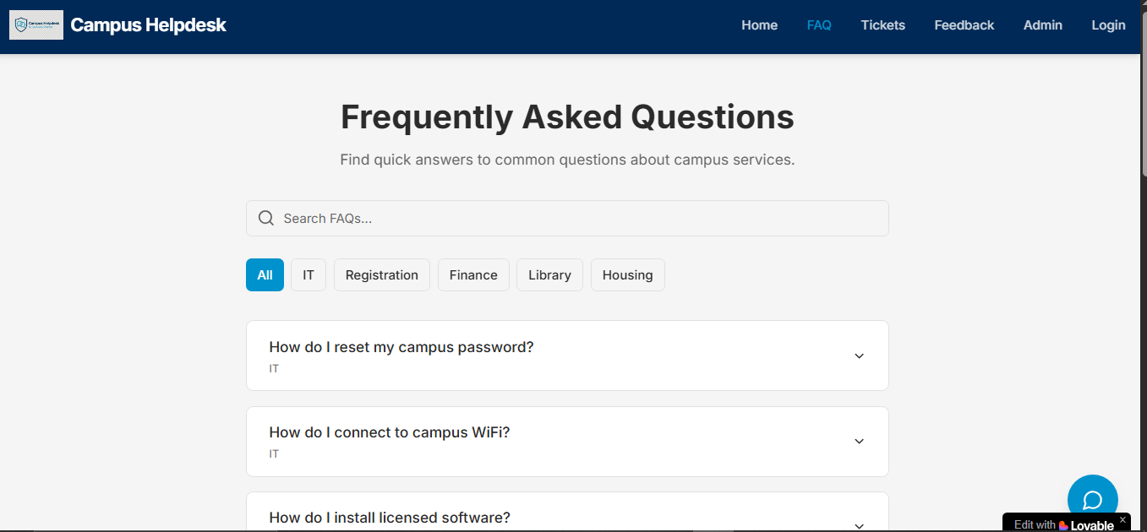
4
3
2
1
Figure 12:FAQ page.

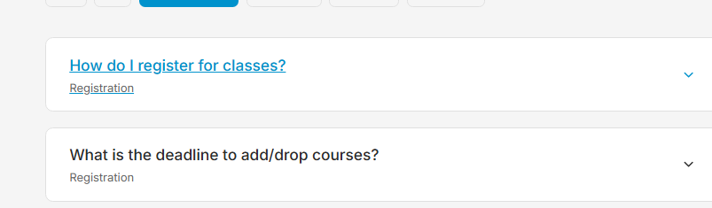
4
Figure 13: registration


5
Figure 14: submit a ticket &chat bot

6

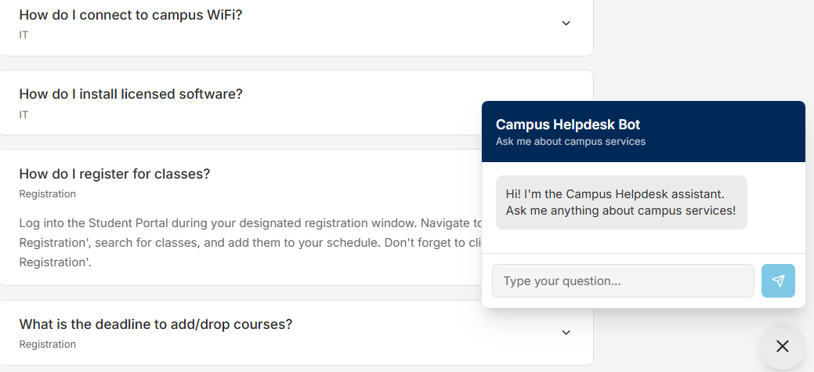
7
Figure 15: Campus Helpdesk Bot

4.5. Frequently Asked Questions (FAQ) Section:
Instant Answer Center for Frequently Asked Questions about University Services.

Instructions:
- Search: type a word to find an answer.
- All: Sort by department (Technical, Registration, Finance).
- Questions: Most Frequently Asked Questions.
- Section: The person responsible for the answer appears.
- Additional help: submit a ticket if you can't find a solution.
- This is our chat bot logo. Click on it and enjoy the experience.
- Our campus chat bot is your smart, instant assistant for all university-related services! With a single tap, you can get accurate answers about tickets, submit feedback, access administrative information, and resolve your daily inquiries quickly and smoothly. Designed to be always at your service, it makes your university experience more efficient and enjoyable—without the hassle.
Ask. Get help. Move forward!

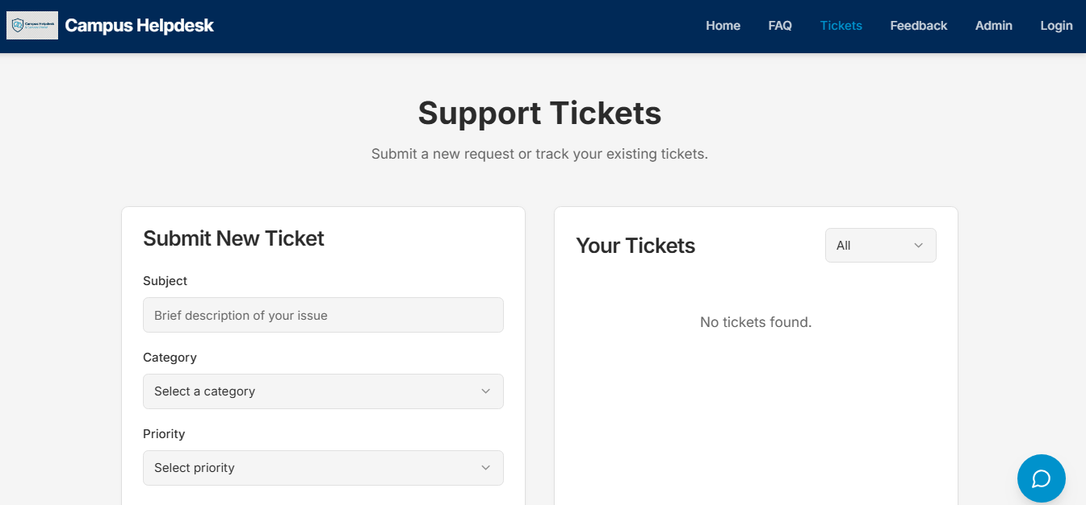
8
7
4
3
2
1

9

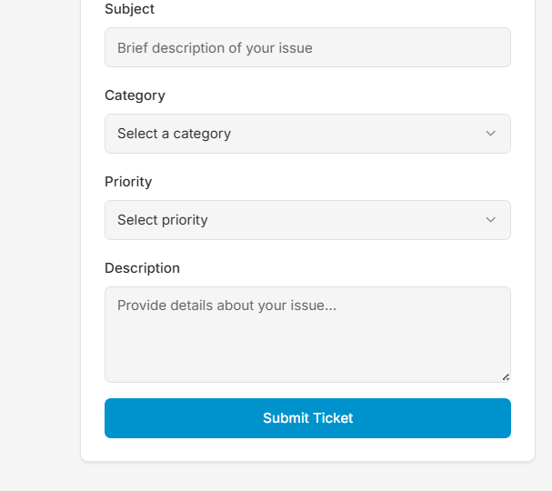
6
5
Figure 16: Submit Ticket

4.6. Uploading Support Tickets (Support Tickets)
Platform for submitting new applications and tracking existing cases

Instructions:
- Upload a new ticket: start the process of creating a new official support request.
- Problem topic: brief description of the problem (example: "Password problem").
- Problem classification: choose the appropriate field: Academic, Technical, Financial, and Administrative.
- Order Priority: Specify Urgency Level: Low, Medium, High, Critical.
- Explain the details: write a full description of the problem along with the steps for troubleshooting.
- Submit Ticket: confirm and Submit Request to System.
- Current support requests you can view and track all your previous support requests.
- All: tickets filter( All, Open, Closed, or Closed)
- No tickets found: no current tickets available - upload a new ticket to begin.

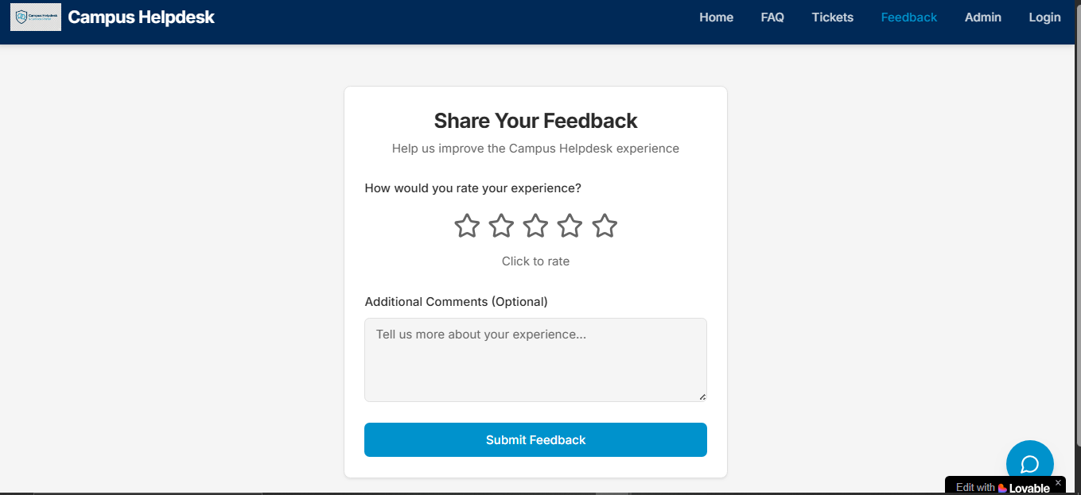
5
3
4
2
1
Figure 17: Rate your experience.

4.7. Evaluation and Feedback
Share your opinion to help us improve our university support service
Instructions:
- Call for evaluation
- The importance of your opinion on improvement.
- Choose your rating from 1-5
- Write notes (if you wish).
- Submit evaluation.

